Ex.No.10. Design a simple topology and configure with one router, two switches and PCs using Cisco Packet Tracer
AIM:
To design and configure a simple network topology with one router, two switches,
and four PCs in Cisco Packet Tracer for successful inter-network communication.
PROCEDURE:

1. Topology
Router R1
┌────────────┐
│ │
G0/0 G0/1
│ │
│ │
Switch S1 Switch S2
┌────┴────┐ ┌────┴────┐
│ │ │ │
PC1 PC2 PC3 PC4
2. Devices to place
In Cisco Packet Tracer, place:
• 1 Router – Cisco 1941
• 2 Switches – Cisco 2960
• 4 PCs
Use Copper Straight-Through cables.
3. IP Addressing
Device Interface IP Address Subnet Mask Gateway
R1 G0/0 192.168.1.1 255.255.255.0 —
R1 G0/1 192.168.2.1 255.255.255.0 —
PC1 NIC 192.168.1.10 255.255.255.0 192.168.1.1
PC2 NIC 192.168.1.11 255.255.255.0 192.168.1.1
PC3 NIC 192.168.2.10 255.255.255.0 192.168.2.1
PC4 NIC 192.168.2.11 255.255.255.0 192.168.2.1
So we have two different networks:

Network 1: 192.168.1.0/24
PC1 ─┐
PC2 ─┤
S1 ─── R1 G0/0 = 192.168.1.1
Network 2: 192.168.2.0/24
PC3 ─┐
PC4 ─┤
S2 ─── R1 G0/1 = 192.168.2.1
4. Configure Router R1
Click R1 → CLI and enter:
enable
configure terminal
interface gigabitEthernet 0/0
ip address 192.168.1.1 255.255.255.0
no shutdown
exit
interface gigabitEthernet 0/1
ip address 192.168.2.1 255.255.255.0
no shutdown
exit
end
write memory
The important command is:
no shutdown
It activates the router interface.
Check the interfaces using:
show ip interface brief
You should see the interfaces as up/up.

OUTPUT:
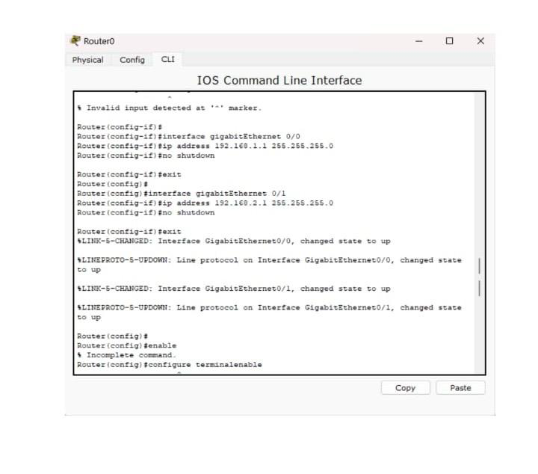
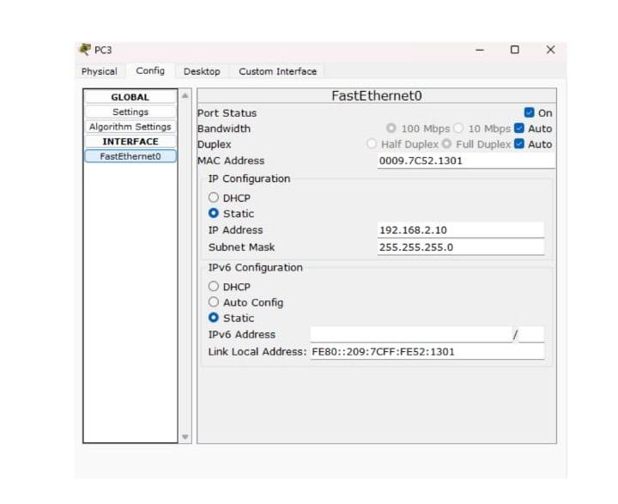
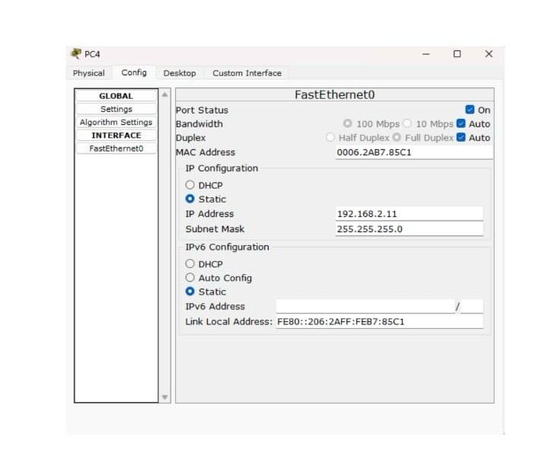
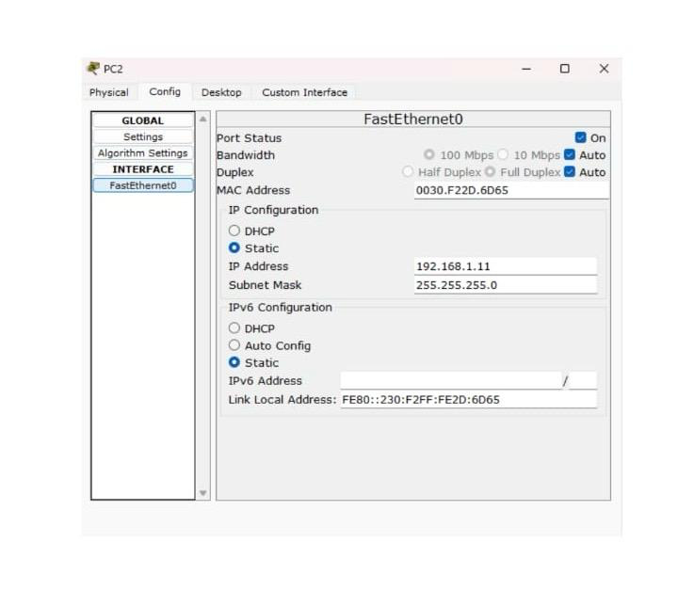
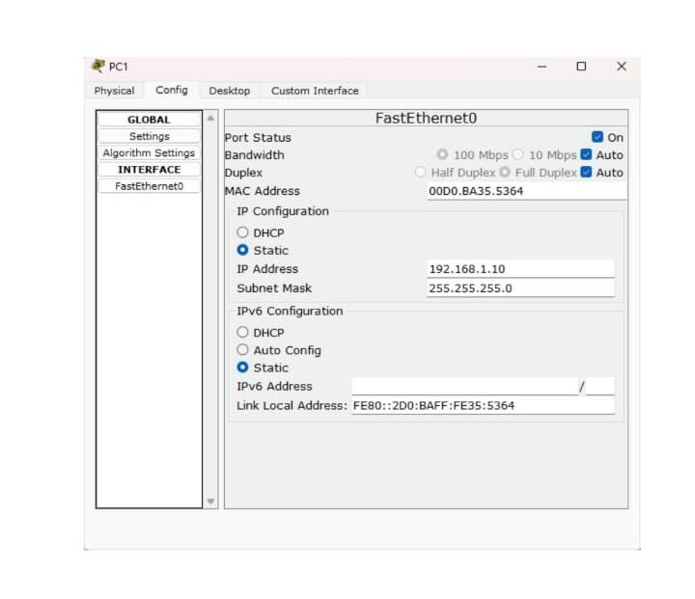
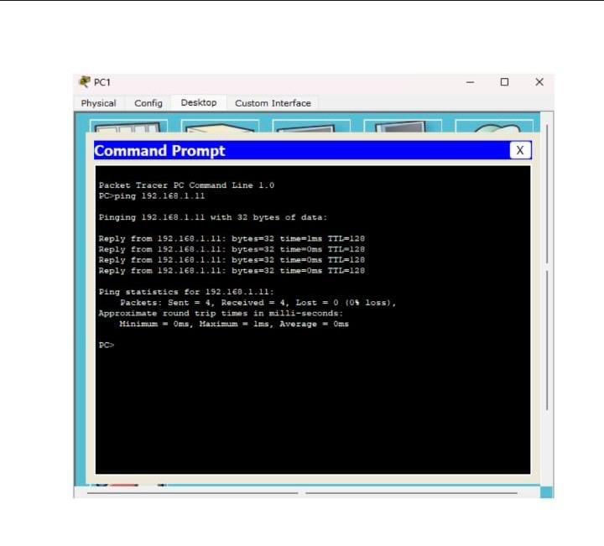

RESULT:
Thus configuration with one router, two switches and PC’s using cisco packet tracer is designed

